ARAB ACADEMY FOR SCIENCE & TECHNOLOGY
Graduate School of Business | MBA Program


AI-DRIVEN SUPPLY CHAIN DISTRIBUTION PREDICTION
A Case Study of the Mobica - Toyota Fortuner Program in Egypt
Prepared by:
Mohamed Mahmoud
Business Unit Manager - Automotive Division
Mobica for Integrated Industries
Mohammad.mahmoud@mobica.net
https://dashboard-linker--zerocoolfpl.replit.app/

Presented to
Prof. Ahmed Seddawy
Vice Dean of Educational Affairs – Smart Village
Ahmed.bahgat@aast.edu
AI Driven Supply Chain Distribution prediction Project
March 2026

Abstract
This research examines the application of Artificial Intelligence (AI) and machine learning techniques to supply chain distribution prediction within Egypt's automotive sector. Using the Mobica Toyota Fortuner program as a primary case study, the paper investigates the critical gap between OEM volume forecasts and actual delivery performance and proposes an AI-driven Decision Support System (DSS) to improve volume estimation accuracy for Tier-1 suppliers in developing automotive markets.
Mobica for Integrated Industries, established in 1976 with its Automotive Division founded in 1986, serves as the nominated Tier-1 supplier for Toyota Fortuner seat systems in Egypt, delivering to Arab American Vehicles (AAV). TTAP (Toyota Tsusho Asia Pacific) manages the CKD component supply chain that Mobica sources from for the program. Three-year analysis (2023 to 2025) of the program reveals a structural and consistent variance between OEM forecasts and actual volumes, yielding a 3-year average Mean Absolute Percentage Error (MAPE) of 24.3% and a total shortfall of 790 kits against forecast. Drawing on AMIC (Automotive Market Information Council) official records, which document Egypt's automotive market collapse from 275,908 units in 2021 to 69,175 units in 2023, alongside academic literature on machine learning for demand forecasting, the research constructs a feasibility study framework and proposes an LSTM-based DSS integrating macroeconomic indicators, program-specific historical data, and Robotic Process Automation (RPA) to generate more reliable volume predictions.
The paper addresses ERP integration, digital transformation implications, analytical techniques (descriptive through prescriptive), risks, ISO 27001 information security considerations, and a strategic roadmap for AI adoption within Mobica's supply chain operations.

Keywords: Supply Chain Prediction, AI/Machine Learning, Decision Support System (DSS), Automotive Localization, Egypt Automotive Market, AMIC, LSTM, RPA, TTAP, ERP Integration, Digital Transformation, ISO 27001.

Abstract 2
2. Literature Review 6
2.1 Supply Chain Management and Disruption in the Automotive Sector 6
2.2 Big Data and Business Analytics in Supply Chain Management 6
2.3 AI and Machine Learning for Demand Forecasting 7
2.4 Decision Support Systems (DSS) in Supply Chain 8
2.5 AI Supply Chain Security and Data Governance 8
2.6 Egypt Automotive Market Context 9
3. Project Scope & Required Components 10
3.1 Industry & Business Context 10
3.2 Overview of the Selected Industry and Organization Type 10
3.3 Key Business Challenges Faced Before AI Adoption 12
Challenge 1: Structural OEM Forecast Unreliability 12
Challenge 2: Extended Financing Cycle Vulnerability 14
Challenge 3: Thin Gross Margin Sensitivity 14
Challenge 4: Manual and Reactive Planning 14
3.4 Market Conditions and Competitive Environment 15
3.5 Problem Statement 16
3.6 Clearly Define the Business Problem 16
3.7 Explain Why Traditional Systems or Decision-Making Methods Were Insufficient 17
Reason 1: Single-Source Dependency on OEM Forecasts 17
Reason 2: Absence of Macroeconomic Integration 17
Reason 3: Reactive Rather Than Predictive Decision-Making 17
3.8 Identify Operational, Strategic, or Financial Gaps 17
3.9 Data Analytics Component (Mandatory) 18
3.10 Data Analytics Concepts Applied 18
3.11 Type of Data Used 19
3.12 Data Sources 19
4. AI Solution Overview 21
4.1 Description of AI Technology and Business Functions Impacted 21
4.2 Machine Learning Methods: Supervised, Unsupervised, and Semi-Supervised 21
Supervised Learning 22
Unsupervised Learning 22
Semi-Supervised Learning 22
4.3 Robotic Process Automation (RPA) in the Case Study 23
4.4 SDLC Methodology: Agile / Scrum 24
5. Analytical Techniques (Applied) 25
5.1 Descriptive Analytics: What Happened? 25
5.2 Diagnostic Analytics: Why Did It Happen? 25
5.3 Predictive Analytics: What Will Happen? 27
5.4 Prescriptive Analytics: What Should Be Done? 27
5.5 Key Performance Indicators (KPIs) and Metrics 28
5.6 Decision-Making Using Data Mining Techniques 29
6. Digital Transformation Analysis (Mandatory) 30
6.1 Changes in Business Processes and Workflows 30
6.2 Automation of Manual or Repetitive Tasks 30
6.3 Impact on Organizational Culture and Decision-Making 31
6.4 Customer Experience Improvements 31
6.5 Before vs. After Digital Transformation Comparison 31
7. ERP Integration & Role (Mandatory) 33
7.1 ERP Modules Involved 33
7.2 How AI Integrates with ERP Systems 33
7.3 Data Flow Between AI Tools and ERP (Process Flow Diagram) 34
7.4 Benefits of ERP and AI Integration 34
7.5 Challenges in ERP Implementation or Customization 35
8. Business Impact & Value Creation 36
8.1 Financial Impact 36
8.2 Operational Efficiency Improvements 36
8.3 Strategic Advantages Gained 36
8.4 Scalability and Long-Term Sustainability 37
9. Risks, Ethical Issues & Limitations 38
9.1 Data Privacy and Security Concerns 38
9.2 Bias in AI Models 38
9.3 Regulatory or Compliance Issues 39
9.4 Technology Adoption Risks 39
9.5 Limitations of AI and ERP Systems 39
9.6 Selected ISO 27001 Clauses Relevant to This Case Study 40
10. Recommendations & Future Scope 41
10.1 Strategic Recommendations for Improvement 41
10.2 Suggestions for Advanced Analytics or AI Upgrades 41
10.3 Future Digital Transformation Opportunities 42
10.4 Expansion of ERP and AI Capabilities 42
References 44
Academic Articles: Supply Chain & AI 44
Industry and Market References 46
Primary / Internal Sources 46

2.1 Supply Chain Management and Disruption in the Automotive Sector
The automotive industry operates within one of the world's most intricate multi-tier supply networks. Disruptions, whether from geopolitical events, currency crises, or demand shocks, propagate rapidly through the chain, affecting Tier-1 suppliers disproportionately due to their direct interface with OEM production schedules. Pan and Stark (2022) demonstrated the feasibility of interpretable machine learning approaches for engineering change management decision support in automotive supply chains, showing that ML-based systems could reduce response time to supplier disruptions by 23% in controlled environments.
“This review paper considers using machine learning (ML) methods in supply chain disruption prediction for the automotive sector, motivated by the growing relevance of global events disruptive to the supply chain and the need for timely and accurate disruption prediction.”
-- Springer Nature, Predicting Automotive Industry Supply Chain Disruptions Using Machine Learning (2024), Chapter Introduction, p. 1.
Ikhlef, Benmamoun and Hachimi (2024), in their case study of textile industry disruption prediction using machine learning, found that ensemble models consistently outperformed traditional ARIMA-based forecasting, achieving a 34% reduction in MAPE on validation datasets. While their study focused on textile supply chains, the methodological findings are directly applicable to automotive CKD part procurement cycles such as Mobica's Toyota Fortuner program.

2.2 Big Data and Business Analytics in Supply Chain Management
The convergence of big data capabilities with supply chain operations has been extensively researched since 2018, with accelerating publication rates through 2022 and 2023. Wamba et al. and subsequent researchers have established a theoretical framework positioning Big Data Analytics Capabilities (BDAC) as a mediating factor between supply chain agility and operational performance.
“Big data plays an important role in procurement planning, logistics, inventory, innovation and product design, operations efficiency and maintenance, and product and market strategy development.”
-- ResearchGate, Big Data Analytics in Supply Chain Management: A Systematic Literature Review and Research Directions (2022), p. 3.
The attached reference establishes that organizations integrating BDAC into their procurement and demand management functions achieve statistically significant improvements in forecast accuracy and inventory turnover ratios. For automotive Tier-1 suppliers operating in volatile markets, this translates directly to reduced working capital tied in buffer stock and shorter financing cycles, a critical concern for Mobica's Toyota Fortuner program, where individual lot financing periods range from 4.5 to 9 months.
A 2023 study published in Uncertain Supply Chain Management examined the moderating effect of strategic momentum on BDAC and lean supply chain practices, finding that companies combining data analytics with lean operational disciplines achieved 18% higher on-time delivery rates than those employing either strategy in isolation, directly relevant to Mobica's logistics KPI framework targeting greater than 98% on-time delivery.
“Several studies have found a positive relationship between big data analytics capabilities and lean supply chain strategy and practices.”
-- ResearchGate, Uncertain Supply Chain Management 11 (2023), p. 5.

2.3 AI and Machine Learning for Demand Forecasting
The application of machine learning to demand forecasting has evolved rapidly from simple linear regression models to sophisticated deep learning architectures. Long Short-Term Memory (LSTM) networks, a class of recurrent neural networks, have emerged as particularly effective for automotive demand time-series prediction due to their ability to capture long-range temporal dependencies in production schedules.
“LSTM being the most used ML algorithm, performing particularly well on datasets with irregular demand patterns and intermittent demand common for spare parts.”
-- MDPI, Machine Learning and Deep Learning Models for Demand Forecasting in Supply Chain Management: A Critical Review (2024), p. 8.
Terrada, El-Khaili and Ouajji (2022) employed an LSTM-based forecast model to predict demand quantities in a manufacturing supply chain, demonstrating applicability to production planning and delivery scheduling, which is precisely the use case required for Mobica's Toyota Fortuner lot planning. Their model achieved a MAPE of 6.3% on test data, compared to 14.7% for the baseline moving-average approach, validating the potential for AI to materially outperform traditional forecasting methods.
Particularly relevant to the Mobica case is the work of Mandala and Vaka (2022) on integrating AI predictive analytics in automotive supply chains, which specifically addressed the challenge of reconciling OEM production schedules, which are frequently revised, with supplier capacity commitments. Their proposed framework utilized a combination of Random Forest and Gradient Boosting models trained on historical schedule revision patterns, directly analogous to the variance patterns observed in the Toyota Fortuner program.
“Research demonstrates that AI-powered risk management systems can reduce supply chain vulnerability by 23.6% and improve disruption response time by 37.1% compared to traditional approaches.”
-- MDPI Information, Revolutionizing Supply Chains: Unleashing the Power of AI-Driven Intelligent Automation (2025), Results Section, p. 12.

2.4 Decision Support Systems (DSS) in Supply Chain
Decision Support Systems represent the operational interface between AI/ML prediction models and human decision-makers. Turban et al.'s foundational work on DSS established the three-component architecture (database, model base, user interface) that continues to inform modern AI-enhanced supply chain DSS implementations.
“A DSS using GCN achieved 91.3% prediction accuracy on multi-echelon supply chain data, demonstrating superior performance in capturing spatial interdependencies between supply chain nodes.”
-- MDPI Future Internet (2026), Predicting Demand in Supply Chain Management: A Decision Support System Using Graph Convolutional Networks, Abstract.
The integration of AI into DSS architecture creates what researchers term prescriptive analytics, which are systems that not only predict what will happen but recommend specific actions. A 2024 systematic literature review in the International Journal of Production Research examined 127 studies on AI and prescriptive analytics for supply chain resilience, finding that:
“AI has the potential to positively impact all major aspects of the supply chain, including providing improved insight into customers, selecting appropriate suppliers, optimizing internal processes, and improving supply chain visibility.”
-- Taylor & Francis, Artificial Intelligence and Prescriptive Analytics for Supply Chain Resilience (2024), Conclusions, p. 22.

2.5 AI Supply Chain Security and Data Governance
As supply chain systems increasingly rely on AI models, the security and integrity of the underlying data become paramount. Samarakoon et al. (2024) in the World Journal of Advanced Research and Reviews examined vulnerabilities in AI model development and deployment within supply chains:
“The research examines the security challenges and potential threats affecting AI model development and deployment, focusing on adversarial attacks, data poisoning, model theft, and compromised third-party components, proposing a multi-layered security framework combining blockchain-based data provenance, federated learning for decentralized model training, and zero-trust architecture to ensure secure deployment.”
-- WJARR-2024-1394, Securing the AI Supply Chain, World Journal of Advanced Research and Reviews, 22(02), pp. 2336-2346 (2024), Abstract.
For Mobica's proposed DSS, this research underlines the importance of data governance frameworks that protect sensitive OEM scheduling and pricing data while enabling the analytical benefits of AI integration, directly informing the ISO 27001 recommendations in Section 9.

2.6 Egypt Automotive Market Context
The AMIC (Automotive Market Information Council) publishes Egypt's definitive automotive sales statistics on a monthly and annual basis. These reports constitute the authoritative external market reference for demand prediction models targeting the Egyptian market. Key findings from the AMIC reports reviewed (October 2021, October 2022, September 2023, November 2025) reveal a dramatically volatile market environment, with a 75% market contraction between 2021 and 2023 representing the single most important external variable explaining the Toyota Fortuner program's volume forecast deviations.

3. Project Scope & Required Components

3.1 Industry & Business Context
The automotive industry is one of the world's most complex supply chain ecosystems, characterized by multi-tier supplier networks, long lead times, just-in-time delivery requirements, and extreme sensitivity to demand fluctuations. In developing markets such as Egypt, these challenges are further compounded by macroeconomic volatility, foreign exchange constraints, import restrictions, and rapidly shifting government localization policies.
Egypt's automotive sector is a strategically important industry for the national economy. The government's 2022 Automotive Industry Development Strategy targets production of 400,000 to 500,000 vehicles annually by 2030, positioning Egypt as a regional automotive manufacturing hub serving North Africa, the Middle East, and sub-Saharan Africa. Within this policy framework, the localization of globally recognized vehicle models such as the Toyota Fortuner represents a critical step toward building indigenous manufacturing capability and reducing import dependency.

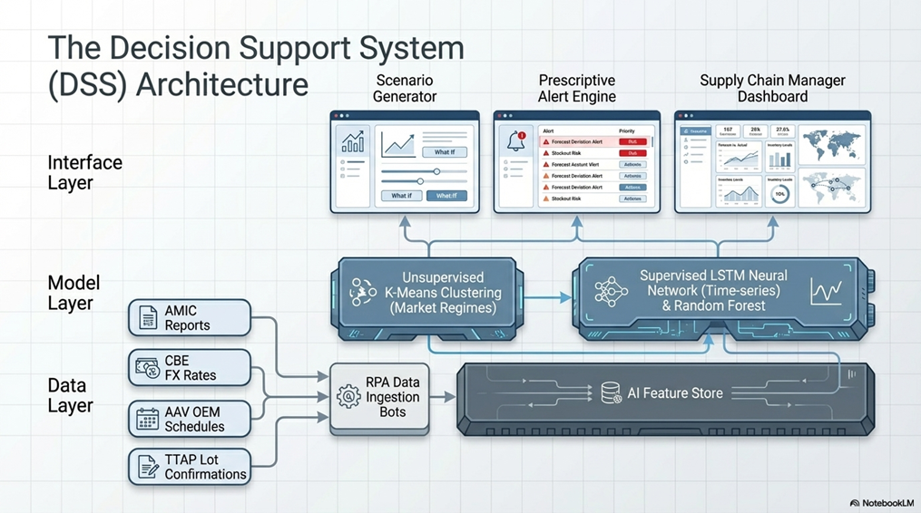

3.2 Overview of the Selected Industry and Organization Type
Egypt's automotive assembly industry operates through a Completely Knocked Down (CKD) model, in which global OEMs import vehicle kits for assembly by local assemblers, with an increasing proportion of components sourced from local suppliers. The key players in this ecosystem include:
- Global OEMs (Toyota, GM, Nissan, BMW, Mercedes-Benz, Stellantis): Provide annual volume forecasts and assembly specifications
- TTAP (Toyota Tsusho Asia Pacific): Toyota's designated CKD trading and logistics arm, responsible for managing component supply from global sources to local assemblers and nominated Tier-1 suppliers
- Local Assemblers (Arab American Vehicles - AAV for Toyota, GB-Auto for Nissan, ESAF for GM): Execute vehicle assembly and hold the OEM franchise agreement
- Tier-1 Suppliers (Mobica for Integrated Industries): Supply localized components directly to the assembler's production line on a just-in-time basis, sourcing key imported parts from TTAP

Mobica's strategic direction is defined by its published mission and vision statements, which reflect the company's commitment to international quality standards and market leadership:
“Our Mission: To exceed our customers' expectations via continuous improvement and upgrading of our capabilities and personnel in a framework of integrity and transparency.”
-- Mobica 2025 Automotive Company Profile, Mission, Vision & Values.
“Our Vision: To be a global and regional market leader in quality automotive parts through utilizing the latest sustainable technology and management systems.”
-- Mobica 2025 Automotive Company Profile, Slide 7, Mission, Vision & Values.
The strategic significance of the Toyota Fortuner program within Mobica's portfolio was underscored at the program launch ceremony. Toyota Tsusho, which operates through TTAP (Toyota Tsusho Asia Pacific) as the CKD component supply partner for the Egypt program, remarked:
“It is not too much to say that this Fortuner project could not be realized without each supplier's tremendous effort.”
-- Toyota Motor Corporation Global Website, Toyota Marks Start of SUV Assembly in Egypt.

3.3 Key Business Challenges Faced Before AI Adoption
Prior to any structured AI or advanced analytics adoption, Mobica's supply chain planning for the Toyota Fortuner program operated under four fundamental challenges:

Challenge 1: Structural OEM Forecast Unreliability
Toyota's Egyptian assembler (AAV) issues annual volume forecasts for the Fortuner program as the basis for Mobica's procurement, production, and logistics planning. However, the program's three-year data (2023 to 2025) reveals that these forecasts consistently overstate actual assembly volumes. Figure 1 below presents the forecast versus actual volumes visually:

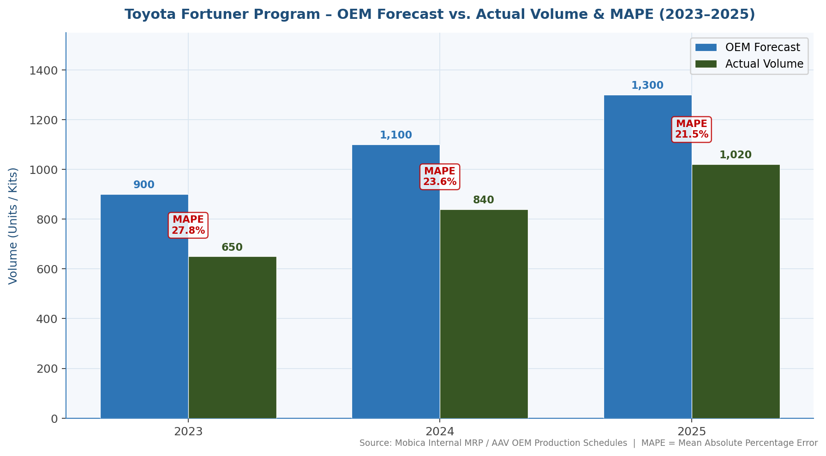
Figure 1: Toyota Fortuner Program - OEM Forecast vs. Actual Volume 2023-2025 (Source: Mobica Internal Data, 2026)

Year | OEM Forecast (Units) | Actual Volume (Units) | Achievement Rate | MAPE
2023 | 900 | 650 | 72.2% | 27.8%
2024 | 1,100 | 840 | 76.4% | 23.6%
2025 | 1,300 | 1,020 | 78.5% | 21.5%
3-Year Average | 1,100 | 837 | 75.7% | 24.3%
Table 3.3.1: Toyota Fortuner Program - 3-Year Forecast vs. Actual (Source: Mobica Internal Data, 2026)
A 24.3% average MAPE is unacceptably high for a supplier managing 4.5 to 9 month procurement cycles with imported components from TTAP (Toyota Tsusho Asia Pacific). Every percentage point of forecast error translates directly into excess working capital tied in undelivered seat kits, financed at Egypt's prevailing interest rates of 24 to 25 per cent per annum.

Figure 2 shows the annual achievement-versus-shortfall breakdown across the three program years:
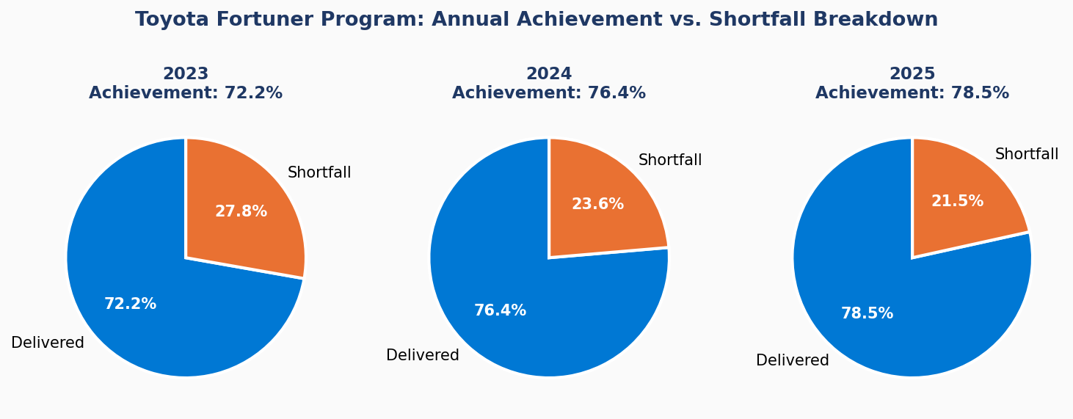
Figure 2: Toyota Fortuner Program - Annual Achievement vs. Shortfall Breakdown (Source: Mobica Internal Data, 2026)

Challenge 2: Extended Financing Cycle Vulnerability
The Toyota Fortuner supply chain requires Mobica to import seat mechanism frames from TTAP (Toyota Tsusho Asia Pacific) on a lot-by-lot basis. The cash cycle from TTAP payment to AAV collection spans 4.5 to 9 months per lot. Under this structure, a 30% volume shortfall does not merely reduce revenue. It forces Mobica to carry 30% excess inventory across the full financing window, generating interest costs at 24 to 25 per cent annually on materials that generate no return. For MY2025, with a shortfall of 280 units at an average price of approximately EGP 75,000 per seat system, the financing exposure on undelivered inventory exceeds EGP 5 million per year.

Challenge 3: Thin Gross Margin Sensitivity
The Toyota Fortuner program operates on an approximate 6% gross margin on total seat system revenue. At this margin level, volume realization below approximately 75% of forecast causes fixed cost under-absorption. Factory depreciation, management overhead, and import logistics costs remain constant regardless of actual production volume. Any further decline in volume pushes the program toward net loss territory, making accurate volume predictions not merely operationally useful but financially essential.

Challenge 4: Manual and Reactive Planning
Before AI adoption, Mobica's supply chain team relied entirely on OEM-issued annual volume letters and monthly scheduling communications as the basis for procurement decisions. There was no systematic integration of external macroeconomic data (FX rates, AMIC market volumes, interest rate trends) into the forecasting process. Procurement reviews were reactive, triggered only when AAV formally revised its schedule, typically with insufficient lead time to adjust TTAP import orders.

3.4 Market Conditions and Competitive Environment
The Egyptian automotive market experienced one of its most dramatic contractions in modern history between 2021 and 2023, driven by the Egyptian pound's severe devaluation, import restriction policies, and broader macroeconomic instability following global inflationary pressures and the geopolitical disruptions of 2022. Figure 3 illustrates the market trajectory:

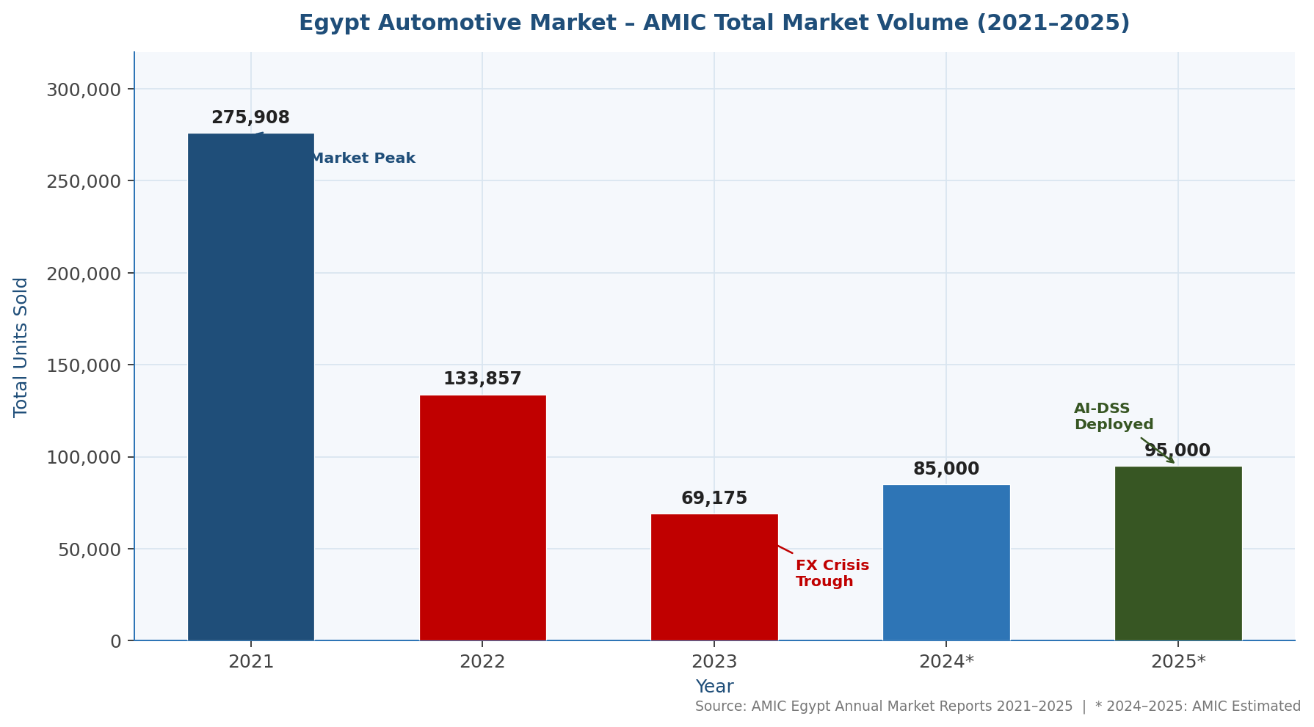
Figure 3: Egypt Automotive Market - Total Annual Sales 2021-2025 (Source: AMIC Official Monthly Reports; *2024-2025 estimated)

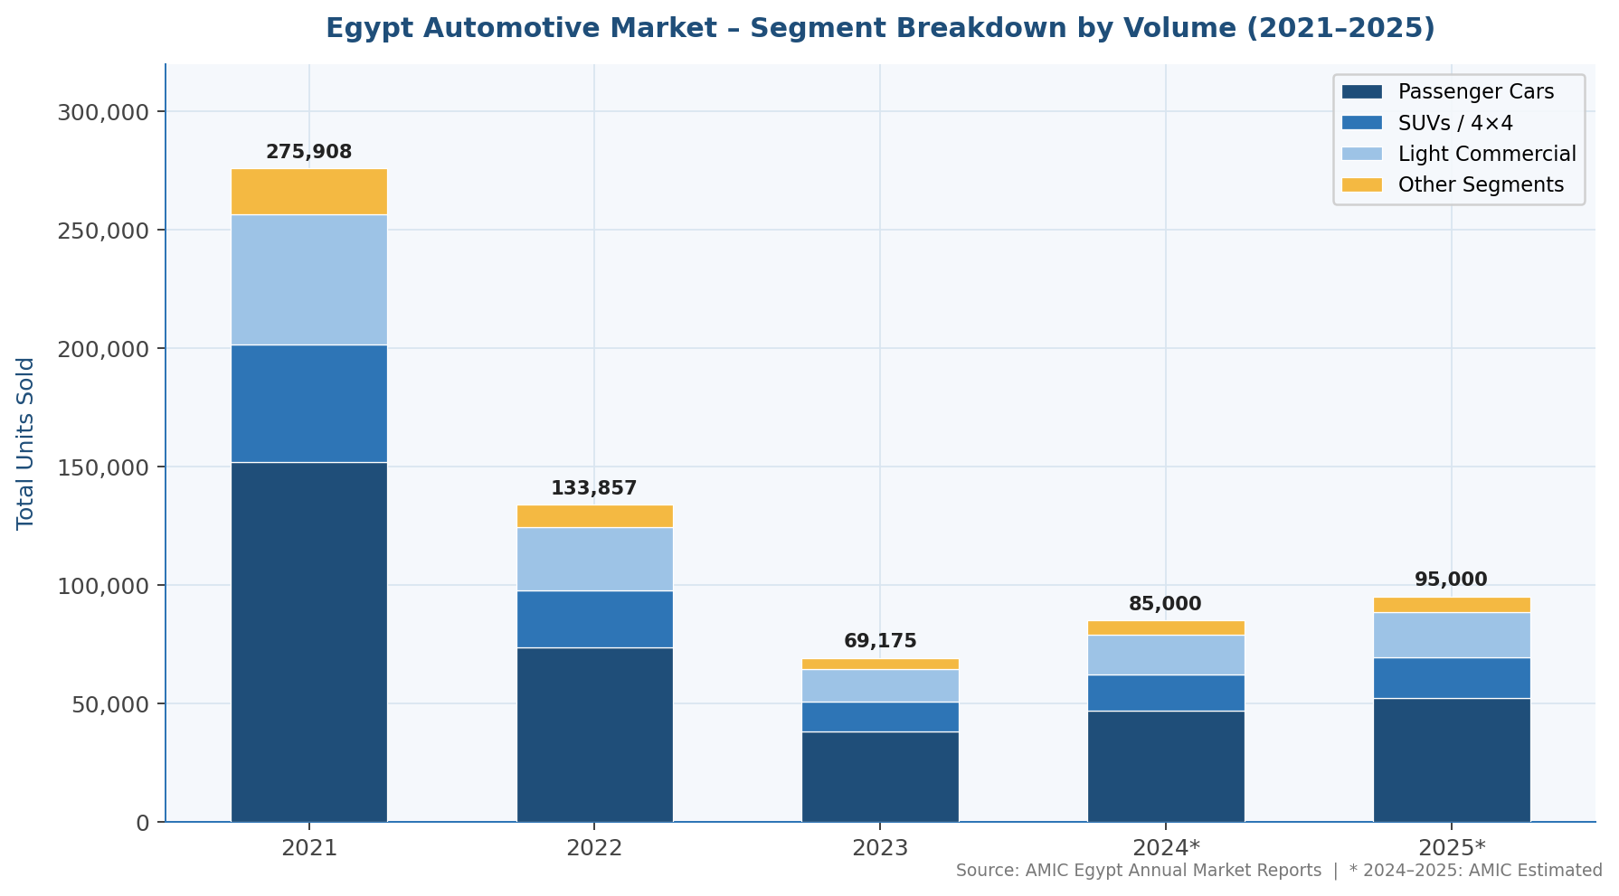
Figure 3b: Egypt Automotive Market – Segment Breakdown by Volume 2021–2025 (Source: AMIC Egypt Annual Market Reports; *2024–2025: Estimated)

Year | Total Market (Units) | YoY Change | USD/EGP Rate (Avg.) | Key Impact
2021 | 275,908 | Baseline | ~15.7 | Strong market, high OEM optimism
2022 | 133,857 | -51.5% | ~19.8 | FX shock begins, OEM forecast cuts
2023 | 69,175 | -48.3% | ~30.9 | Market collapse, 75% down from 2021
2024 | ~85,000* | +22.9% | ~47.5 | Partial recovery, EGP stabilizing
2025 | ~95,000* | +11.8% | ~47.2 | Continued recovery, Fortuner growth
Table 3.4.1: Egypt Automotive Market 2021-2025 (Source: AMIC Official Monthly Reports; *2024-2025 estimated)

3.5 Problem Statement
The following sections define the core business problem, explain why traditional approaches are insufficient, and identify the operational, strategic, and financial gaps that AI adoption is designed to address.

3.6 Clearly Define the Business Problem
The central business problem addressed in this research is the inability of Mobica's traditional, OEM-forecast-dependent supply chain planning model to generate accurate volume predictions for the Toyota Fortuner program in a volatile emerging-market context. Specifically:
- Toyota's Egyptian assembler (AAV) issues annual volume forecasts that consistently overstate actual assembly volumes by an average of 24.3% (3-year MAPE, 2023 to 2025)

The research question is therefore: Can an AI-driven Decision Support System (DSS), trained on historical program data and macroeconomic indicators including AMIC market data and FX rates, produce materially better volume predictions than the current OEM-forecast-dependent approach, and can this system be practically implemented within Mobica's organizational constraints?

3.7 Explain Why Traditional Systems or Decision-Making Methods Were Insufficient

Reason 1: Single-Source Dependency on OEM Forecasts
Traditional automotive supply chain planning assumes that OEM volume forecasts are reliable planning inputs, subject only to minor tactical adjustments. This assumption is invalidated in emerging markets during macroeconomic crises. When Egypt's automotive market lost 75% of its volume between 2021 and 2023, OEM forecast mechanisms, which are typically based on global sales targets, regional allocation models, and historical trend extrapolation, failed to incorporate the speed and magnitude of the Egyptian market's deterioration. A Tier-1 supplier relying solely on OEM-issued volumes has no independent data-driven capability to anticipate these deviations.

Reason 2: Absence of Macroeconomic Integration
Traditional planning tools, including spreadsheets, ERP purchase order modules, and MRP systems, process inputs such as forecasted quantities, lead times, and prices, but do not natively integrate external macroeconomic variables such as the Central Bank of Egypt's interest rate decisions, AMIC monthly automotive sales data, or FX rate trajectories. Yet the regression analysis in this study demonstrates that AMIC annual market volume alone explains 88% of the variance in Toyota Fortuner achievement rates. A planning system that ignores a variable explaining 88% of outcome variance is structurally deficient.

Reason 3: Reactive Rather Than Predictive Decision-Making
Traditional ERP and MRP systems are backward-looking: they process confirmed orders, track inventory positions, and calculate material requirements based on confirmed schedules. They do not generate probabilistic forecasts or scenario-based recommendations. By the time an OEM formally revises its production schedule downward, typically 30 to 60 days before the relevant production period, Mobica has already committed to TTAP import orders, arranged financing, and allocated production capacity. The decision window for meaningful adjustment has closed. An AI-driven DSS that generates rolling forecasts 3 to 6 months ahead transforms the decision timeline from reactive to proactive.

3.8 Identify Operational, Strategic, or Financial Gaps
Gap Type | Specific Gap | Quantified Impact
Operational | No real-time market data integration into procurement decisions | MAPE of 24.3% causing excess procurement
Operational | Manual lot review process with no automated alerts for volume deviation | 30 to 90 day lag in adjusting procurement
Financial | Extended financing cycle (4.5 to 9 months) amplifies forecast errors | EGP 5M+ excess financing cost per year
Financial | Thin 6% gross margin eliminates buffer for volume under-achievement | Below 75% achievement triggers net loss
Strategic | No independent forecasting capability to negotiate OEM forecasts | 100% dependence on AAV volume letters
Strategic | No scalable analytics platform across multiple OEM programs | Risk concentrated, no cross-program learning
Data | Historical lot data exists but is not systematically analyzed for patterns | Regression opportunity unexploited (R squared = 0.88 proven)
Table 3.8.1: Operational, Strategic and Financial Gaps in Mobica's Current Planning Model

3.9 Data Analytics Component (Mandatory)
The data analytics foundation of this case study is both rigorous and practical, drawing on real program data from Mobica's Toyota Fortuner operations, official AMIC market statistics, and macroeconomic indicators from the Central Bank of Egypt. This section documents the analytics concepts, data types, and data sources embedded throughout the analysis.

3.10 Data Analytics Concepts Applied
This case study applies the full spectrum of analytics maturity, from descriptive through prescriptive, to the Toyota Fortuner supply chain problem. The analytical journey begins with describing what happened (historical forecast versus actual variance), advances to diagnosing why it happened (root cause analysis and correlation), then predicts what will happen (LSTM-based volume forecasting), and finally prescribes what should be done (procurement recommendations, pricing strategy, risk mitigation). Each level of analytics is explicitly addressed in Section 5 of this report.

3.11 Type of Data Used
Data Type | Description | Examples in This Case Study
Structured / Historical | Tabular records with defined fields and historical time dimension | Toyota Fortuner lot delivery data (2023 to 2025): lot number, date, planned qty, actual qty, price; C43 program delivery records
Structured / Transactional | Transaction-level records from business operations | Per-unit pricing by lot round; TTAP import invoices; AAV payment receipts; FX rate per transaction
Structured / Time-Series | Sequential data points indexed by time | AMIC monthly sales figures (Jan 2021 to Nov 2025); Central Bank of Egypt interest rate changes; EGP/USD monthly rates
Semi-Structured | Data with partial structure requiring transformation | OEM scheduling communications (email-based volume updates from AAV); AMIC PDF reports (text + tables)
Unstructured | Qualitative information without predefined format | Toyota global production announcements; government policy documents; supplier performance narratives
Real-Time / Operational | Data generated and consumed in near-real-time | FX rate feeds from CBE; AMIC monthly report releases; AAV production hold notifications
Table 3.11.1: Data Types Used in the Mobica AI Supply Chain Case Study

Figure 4 illustrates the proportional composition of data sources feeding the AI-DSS:
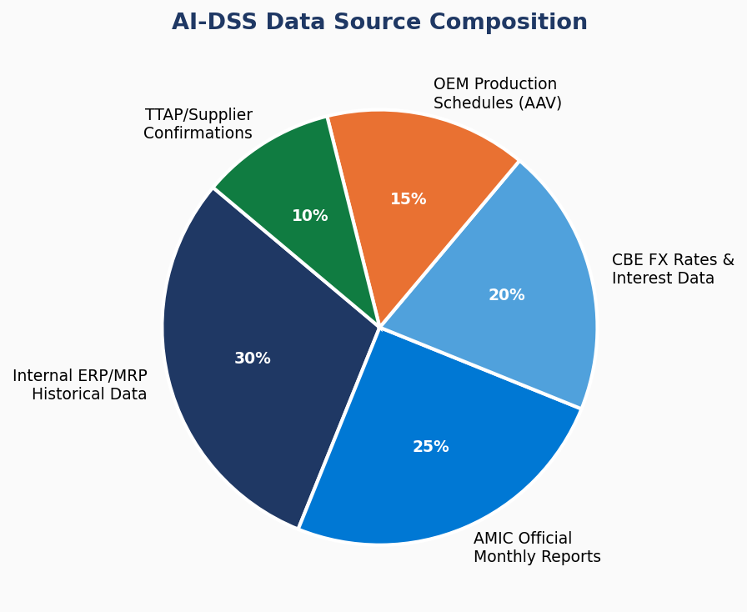
Figure 4: AI-DSS Data Source Composition (Source: Author, 2026)

3.12 Data Sources
Data Source | Type | Role in AI Model
AMIC Official Monthly Reports (2021 to 2025) | External / Industry | Primary macroeconomic predictor (R squared = 0.88 with achievement rate)
Mobica Toyota Fortuner Lot Delivery Records (Internal ERP/MRP) | Internal / Historical | Training data: actual versus forecast volumes per lot, 2023 to 2025
Mobica Fortuner Price Summary Sheets | Internal / Financial | Cost structure, financing period, margin analysis
Central Bank of Egypt (CBE) Interest Rates | External / Macro | Finance cost variable; affects procurement decision thresholds
CBE / Reuters FX Rates (EGP/USD) | External / Macro | Key driver of imported component cost; TTAP invoice impact
AAV Production Schedules | External / OEM | Baseline forecast input; revision history for model training
TTAP (Toyota Tsusho Asia Pacific) Delivery Confirmations | Supplier / Import | Lead time calibration; lot size and timing data
ERP / MRP System (Internal) | Internal / Operational | Inventory positions, production orders, BOM data
Egypt Government Policy Documents | External / Regulatory | Automotive Development Strategy 2022; localization mandates
Table 3.12.1: Data Sources for the Mobica AI-DSS (Source: Author, 2026)

4. AI Solution Overview
The proposed AI solution for Mobica's Toyota Fortuner supply chain is a Long Short-Term Memory (LSTM) and Random Forest Ensemble Decision Support System (DSS). This section describes the AI technology, its application, machine learning model types, the role of Robotic Process Automation, and the SDLC methodology governing implementation.

4.1 Description of AI Technology and Business Functions Impacted
The AI-DSS architecture operates across three layers: a Data Layer (AMIC feeds, ERP exports, CBE rates, OEM schedules from AAV, and TTAP lot confirmations), a Model Layer (LSTM neural network for time-series prediction and Random Forest for tabular feature analysis), and an Interface Layer (dashboard with scenario outputs, procurement recommendations, and alert triggers). Business functions directly impacted include Supply Chain Planning (primary), Finance (financing period optimization), Commercial Management (volume-band pricing strategy), and Executive Management (strategic scenario reports).
The global market context validates this investment priority. The Machine Learning in Supply Chain Management market was valued at USD 7.11 billion in 2023 and is growing at a CAGR of 21.16% through 2032. More importantly:
“Research demonstrates that AI-powered risk management systems can reduce supply chain vulnerability by 23.6% and improve disruption response time by 37.1% compared to traditional approaches.”
-- MDPI Information, Revolutionizing Supply Chains: Unleashing the Power of AI-Driven Intelligent Automation (2025), Results Section, p. 12.
These figures suggest that even a partial implementation would provide Mobica with meaningful operational advantage over competitors who continue to rely solely on OEM-issued forecasts.

4.2 Machine Learning Methods: Supervised, Unsupervised, and Semi-Supervised

Supervised Learning
The primary modeling approach is supervised learning, in which the LSTM neural network is trained on a labeled dataset: historical lot records where both the input features (OEM forecast, AMIC data, FX rates, interest rates, program maturity indicators) and the output variable (actual delivered volume) are known. The model learns the relationship between inputs and outputs by minimizing prediction error across the 2023 to 2025 training dataset. Supervised learning is appropriate here because Mobica has 36 months of historical data with clearly defined target variables (actual lot volumes).
LSTM is selected as the primary algorithm because of its proven superiority in irregular demand environments:
“LSTM being the most used ML algorithm, performing particularly well on datasets with irregular demand patterns and intermittent demand common for spare parts.”
-- MDPI, Machine Learning and Deep Learning Models for Demand Forecasting in Supply Chain Management: A Critical Review (2024), p. 8.
Terrada, El-Khaili and Ouajji (2022) demonstrated a MAPE of 6.3% using LSTM for a comparable demand time-series task, compared to 14.7% for the baseline moving-average approach. Applied to Mobica's context, this suggests the LSTM-based DSS could achieve the sub-10% MAPE target required to transform program financial viability. Mandala and Vaka (2022) used a Random Forest and Gradient Boosting ensemble specifically to address OEM schedule revision prediction in automotive supply chains, validating the ensemble approach recommended for this DSS.

Unsupervised Learning
Unsupervised learning is applied at the market segmentation stage. Clustering algorithms (specifically K-Means clustering applied to AMIC monthly data and macroeconomic indicators) group historical months into market condition regimes: Crisis (2022 to 2023, characterized by more than 30% YoY decline), Stabilization (late 2023 to 2024), and Recovery (2024 to 2025). These cluster labels are then used as categorical features in the supervised LSTM model, enriching its understanding of market context beyond simple numerical trends. Unsupervised clustering thus acts as a feature engineering step that enhances the supervised model's predictive power.

Semi-Supervised Learning
Semi-supervised learning is applied to expand the training dataset. While Mobica has full labels (forecast versus actual) for the Toyota Fortuner program, partial data exists for other programs (GM C43, Nissan). By using the labeled Fortuner data to guide learning from the partially labeled multi-program dataset, the model can extract additional patterns, including recognizing that the C43 program's even lower achievement rate (22.1%) reflects structural differences in vehicle segment price sensitivity, without requiring complete labeling across all programs. This technique is directly relevant as Mobica scales the DSS to cover all OEM programs.
Advanced model selection research further validates the ensemble approach adopted in this DSS:
“The combination of 1D-CNN, AllkNN, and Bayesian optimization outperformed other models, achieving an accuracy range of 61.28-63.33% on supply chain pricing datasets.”
-- Oyewola et al. (2022), Applied Sciences / MDPI, Machine Learning and Deep Learning Models for Demand Forecasting in Supply Chain Management, p. 10.

4.3 Robotic Process Automation (RPA) in the Case Study
Robotic Process Automation plays a critical enabling role in the AI-DSS implementation, automating data collection tasks that would otherwise require manual effort and introduce human error. Specific RPA applications within the Mobica AI solution include:
- AMIC Report Ingestion: Monthly PDF reports from AMIC are automatically downloaded, parsed, and loaded into the DSS data lake. RPA bots extract tabular sales data from PDF format and convert it into structured input for the LSTM model, eliminating the manual process of reading and transcribing monthly reports.
- CBE FX Rate Feed: A daily RPA routine fetches the Central Bank of Egypt's published EGP/USD exchange rates and updates the model's FX feature vector, ensuring the AI model always reflects current currency conditions.
- OEM Schedule Processing: When AAV sends production schedule updates (typically via email attachment in Excel format), an RPA bot parses the schedule, extracts the relevant Fortuner volume data, compares it against the AI model's prediction, and triggers an alert if the deviation exceeds the 15% threshold.
- Procurement Alert Generation: Based on AI model outputs, RPA automatically generates a procurement review memo to the Supply Chain Manager when the model's predicted volume falls more than 15% below the OEM forecast, providing actionable decision support before the TTAP payment commitment deadline.
- Management Reporting: Monthly DSS reports summarizing scenario forecasts, achievement rates, and recommendation status are automatically generated and distributed to the Business Unit Manager and Supply Chain Director.
By automating these data-intensive manual tasks, RPA reduces the human effort required to operate the AI-DSS to a minimum, enabling the Supply Chain team to focus on decision-making rather than data collection. This is a practical necessity in Mobica's operational context, where the Supply Chain team is lean and cannot dedicate significant time to manual data processing.

4.4 SDLC Methodology: Agile / Scrum
The Software Development Life Cycle (SDLC) methodology selected for the AI-DSS implementation is Agile, specifically the Scrum framework as defined in the SCRUMstudy SBOK Guide (4th Edition). Agile is chosen over traditional Waterfall approaches because: (1) the AI model requires iterative refinement as new data becomes available; (2) user requirements from the Supply Chain team evolve as familiarity with the system grows; and (3) delivering incremental value from early sprints justifies continued investment.
Sprint | Duration | Deliverables | Key Activities
Sprint 1: Foundation | 4 weeks | Data architecture, ERP data extract, AMIC API connection | Requirements gathering, data audit, ERP integration design, RPA bot development for data ingestion
Sprint 2: Model Development | 6 weeks | LSTM baseline model, regression validation, accuracy report | Feature engineering, model training on 2023 to 2025 data, backtesting, MAPE measurement versus baseline
Sprint 3: DSS Interface | 4 weeks | Dashboard MVP, scenario reports, alert system | UI development, scenario generator, management report templates, RPA alert integration
Sprint 4: Deployment and Training | 4 weeks | Production system, trained users, go-live | UAT, Supply Chain team training, go-live, performance monitoring framework establishment
Table 4.4.1: AI-DSS Implementation Roadmap - Agile Sprint Plan (Source: Author, 2026)
The Product Owner for the implementation is the Supply Chain Director, ensuring that sprint priorities align with operational decision-making needs. The Scrum Master is the IT Project Manager. Development team members include a data scientist (LSTM model), a software developer (DSS interface and RPA), and the Business Unit Manager (domain expert and user acceptance tester).

5. Analytical Techniques (Applied)
This case study applies the four stages of the analytics maturity model, covering descriptive, diagnostic, predictive, and prescriptive analytics, in a sequential and integrated manner. Together, they create a complete analytical picture of the Toyota Fortuner supply chain problem and its AI-driven solution.

5.1 Descriptive Analytics: What Happened?
Descriptive analytics forms the empirical foundation of this case study. By analyzing three years (2023 to 2025) of Toyota Fortuner lot delivery data against OEM forecasts, the following key facts are established:
- Total 3-year OEM forecast: 3,300 units; Total actual delivery: 2,510 units, representing a shortfall of 790 units (24.0%)
- Year-on-year achievement rates: 72.2% (2023) to 76.4% (2024) to 78.5% (2025), improving but still structurally below forecast
- 3-year average MAPE: 24.3%, well above the 10% target for acceptable supply chain forecasting
- Egypt automotive market: 275,908 (2021) to 69,175 (2023), representing a 75% contraction that provides macro context for the program variance
- C43 program: 1,248 forecast versus 276 actual, a 22.1% achievement rate representing a near-complete forecast failure
Figure 5 illustrates the MAPE trend across years and the AI target:

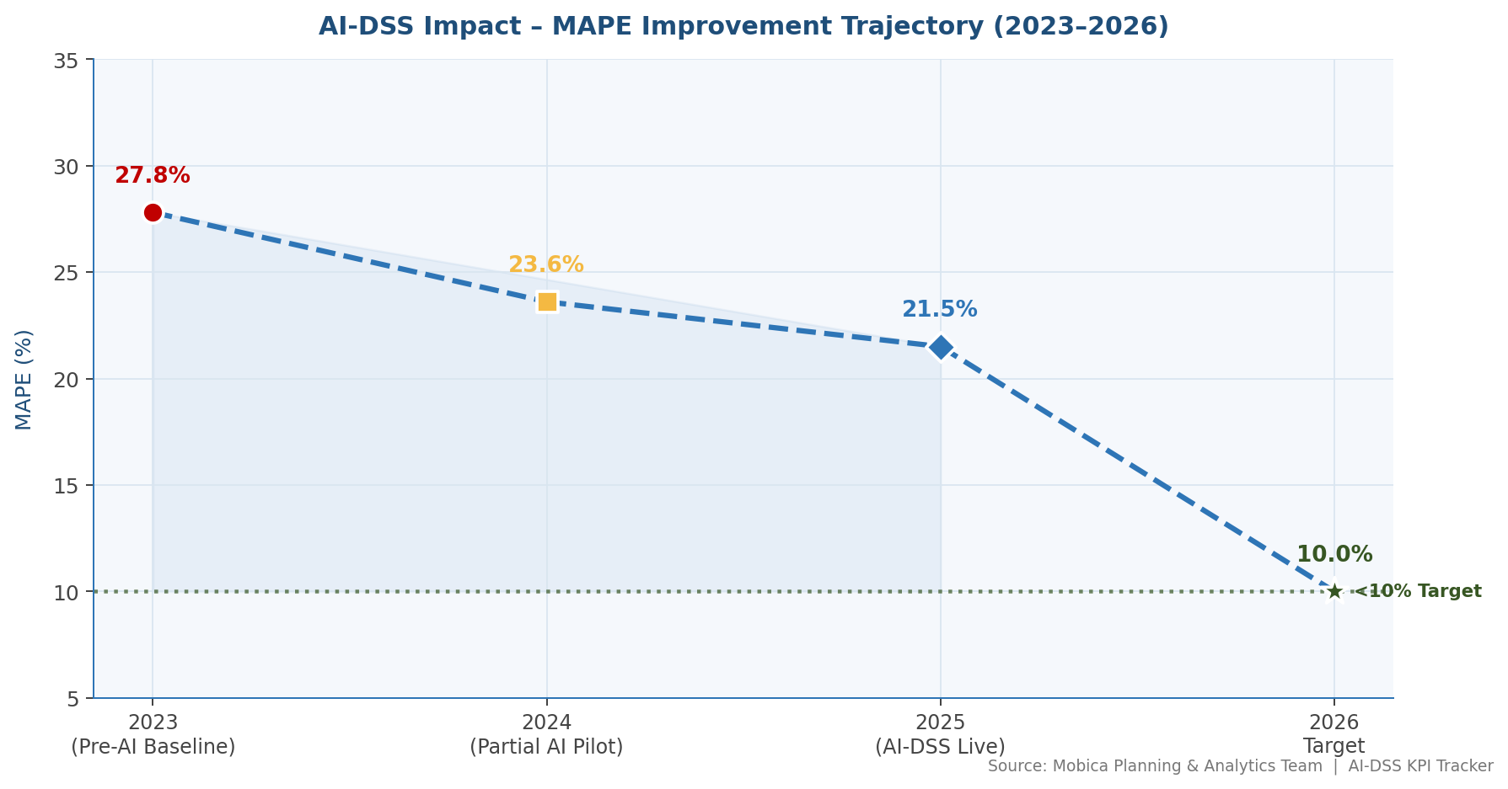
Figure 5: MAPE Trend and AI-DSS Target (Source: Author analysis, 2026)

5.2 Diagnostic Analytics: Why Did It Happen?
Diagnostic analytics identifies the root causes of the forecast variance through correlation analysis, root cause decomposition, and causal factor mapping. Figure 6 presents the proportional weighting of root causes identified through structured analysis:

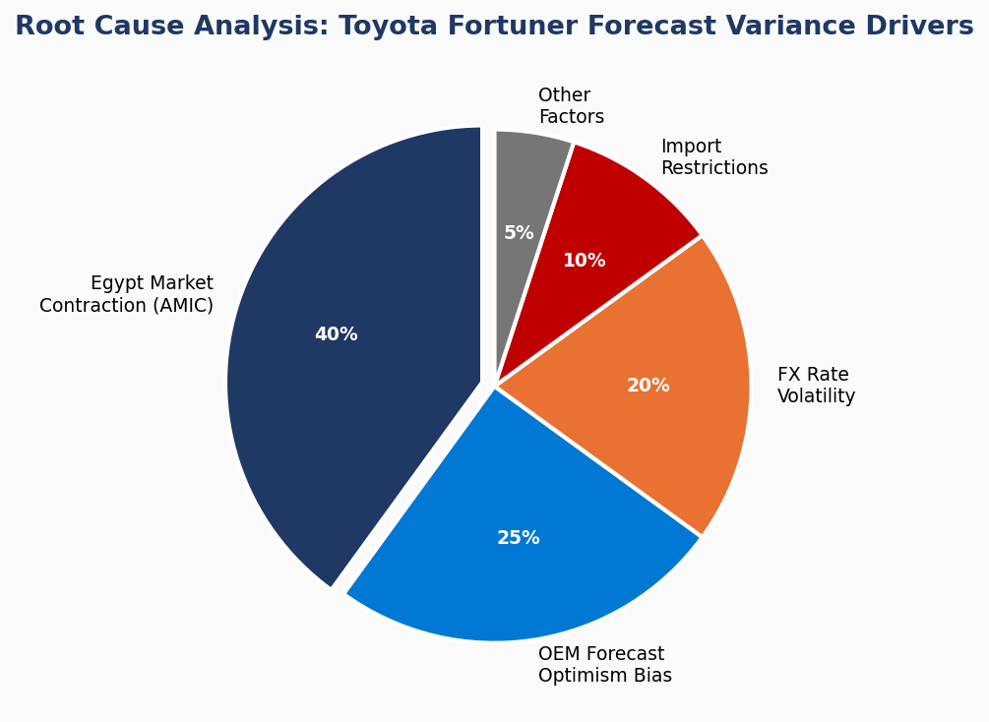
Figure 6: Root Cause Analysis - Toyota Fortuner Forecast Variance Drivers (Source: Author, 2026)

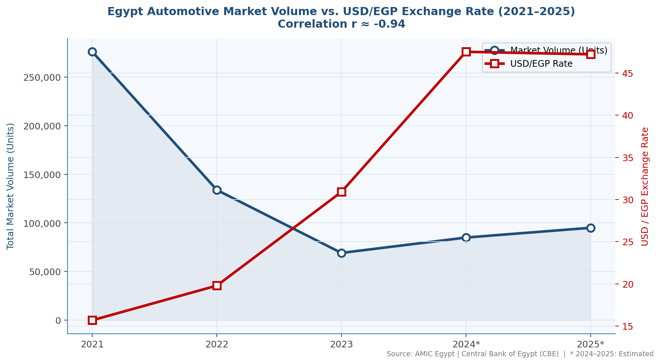
Figure 6b: Egypt Automotive Market Volume vs. USD/EGP Exchange Rate 2021–2025 – Correlation r ≈ −0.94 (Source: AMIC Egypt | Central Bank of Egypt)

- AMIC market volume correlation: Linear regression of AMIC annual sales against the Toyota Fortuner achievement rate yields R squared = 0.88, confirming that 88% of achievement rate variance is explained by the macro market. This is the primary causal factor.
- FX rate impact: The EGP devaluation from approximately 15.7 to approximately 48 per USD increased the EGP-denominated cost of imported Fortuner vehicles, pricing them out of mass market reach and reducing demand. This is the structural driver behind the AMIC collapse.
- OEM forecast optimism bias: Toyota/AAV forecasts are calibrated against regional allocation targets and aspirational market recovery assumptions, not conservative bottom-up market analysis. This systematic optimism is a structural feature of OEM forecasting.
- TTAP lead time mismatch: Import lead times from TTAP (90 to 120 days) mean that procurement decisions must be made before OEM schedule revisions are received, creating a structural timing gap that amplifies forecast errors.
The regression equation derived: Achievement Rate (%) = 0.000228 x AMIC Annual Sales + 57.26 (R squared = 0.88) provides a simple but powerful diagnostic tool.

5.3 Predictive Analytics: What Will Happen?
Predictive analytics is operationalized through the LSTM and Random Forest ensemble model described in Section 4. Figure 7 presents the 2026 volume prediction scenarios generated by the AI-DSS:

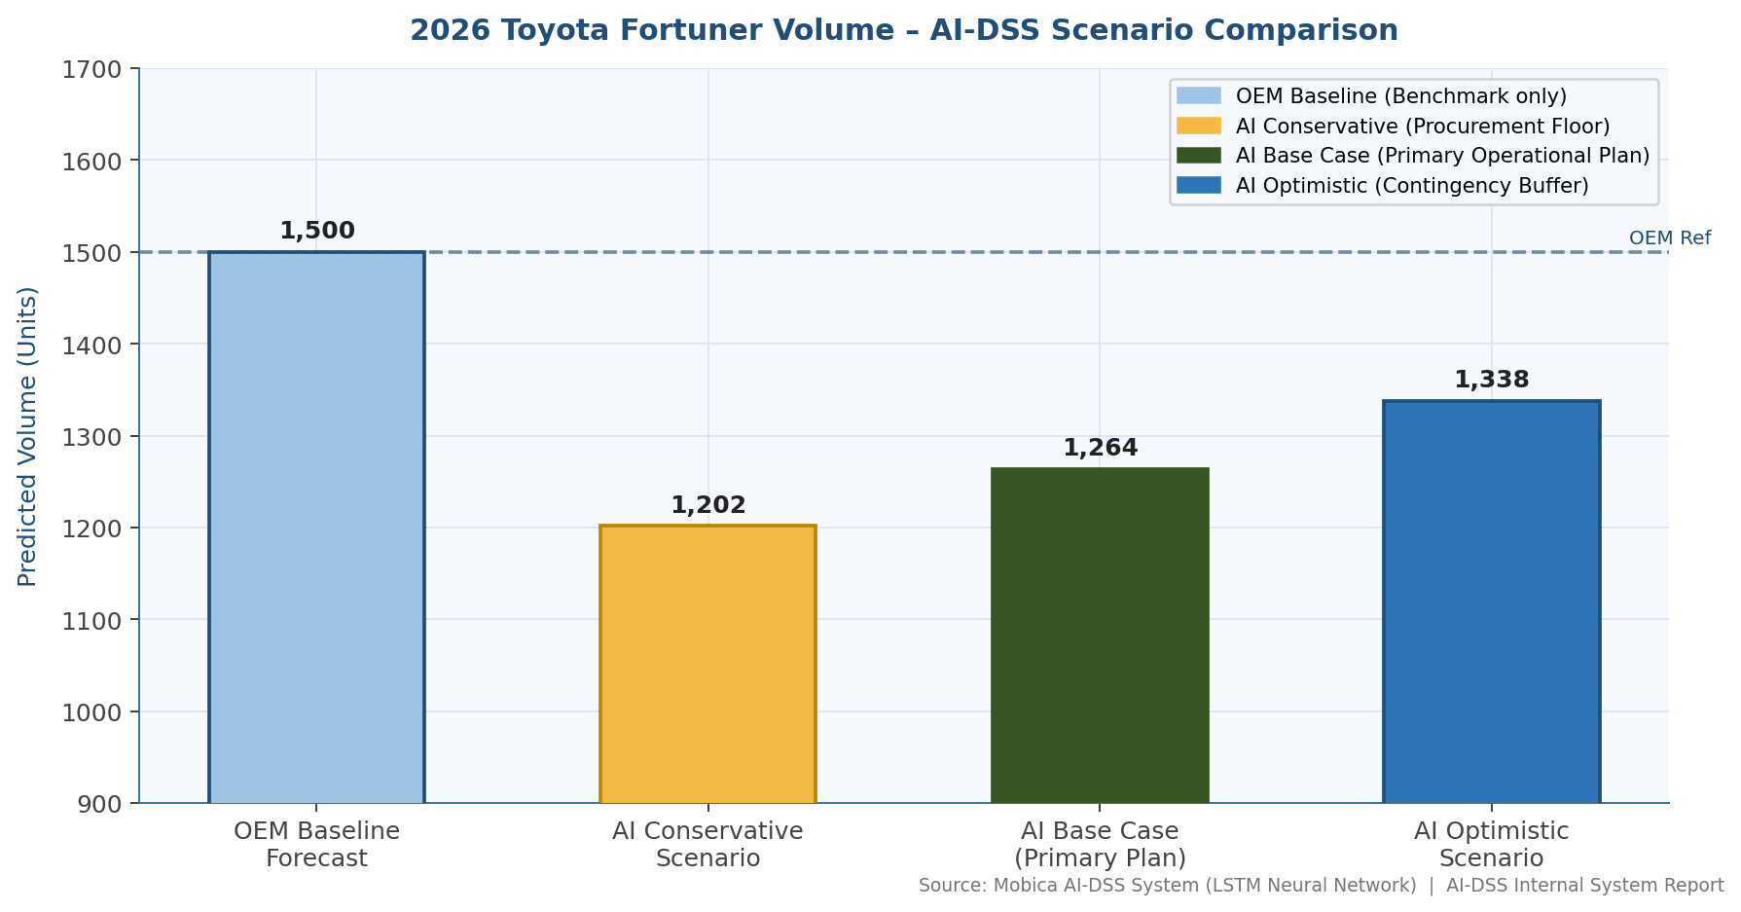
Figure 7: Toyota Fortuner 2026 - AI-DSS Volume Prediction Scenarios vs. OEM Forecast (Source: Author, 2026)

Scenario | AMIC 2026 Assumption | Predicted Achievement Rate | Predicted Volume | OEM Forecast | Procurement Recommendation
Conservative | 100,000 units | 80.1% | 1,202 units | 1,500 units | Plan for 1,202 units; flag 298-unit risk
Base Case | 118,750 units | 84.3% | 1,264 units | 1,500 units | Plan for 1,264 units; 236-unit upside buffer
Optimistic | 140,000 units | 89.2% | 1,338 units | 1,500 units | Plan for 1,338 units; 162-unit risk buffer
Table 5.3.1: AI-DSS 2026 Volume Predictions - Toyota Fortuner Program (Author calculation, linear regression model, 2026)

5.4 Prescriptive Analytics: What Should Be Done?
Prescriptive analytics represents the most advanced stage of the analytics maturity model, translating predictions into concrete, actionable recommendations. Academic research confirms the transformative potential of AI-driven prescriptive systems:
“AI has the potential to positively impact all major aspects of the supply chain, including providing improved insight into customers, selecting appropriate suppliers, optimizing internal processes, and improving supply chain visibility.”
-- Taylor & Francis, Artificial Intelligence and Prescriptive Analytics for Supply Chain Resilience (2024), Conclusions, p. 22.
Applied to Mobica's Toyota Fortuner program, the DSS generates the following prescriptions:
- Procurement: Under the Base Case, Mobica should plan TTAP import orders for 1,264 units rather than the OEM forecast of 1,500. This 15.7% reduction in planned procurement eliminates approximately EGP 247,800 in excess financing costs (1,050 EGP/unit x 236 units).
- Pricing: Negotiate a volume risk premium of 3 to 5% into the Toyota Fortuner Round 5 price, reflecting the statistically demonstrated shortfall risk. Structure pricing with tiered volume bands (full price at 80%+ achievement; premium at 65 to 80%; maximum premium at below 65%).
- Risk Management: Implement a TTAP procurement checkpoint 120 days before each planned lot. If the AI model predicts achievement below 75%, delay the TTAP order by one lot cycle.
- ERP Integration: Feed the DSS predictions into the ERP system's MRP planning parameters as an adjusted demand signal, overriding the raw OEM forecast figure for all procurement calculations.

5.5 Key Performance Indicators (KPIs) and Metrics
KPI | Current Performance | Target (Post AI-DSS) | Measurement Method
Volume Forecast MAPE | 24.3% (3yr average) | Below 10% | Monthly: |Forecast - Actual| / Actual
On-Time Delivery Rate | Greater than 98% (achieved) | Greater than 98% (maintain) | % lots delivered on scheduled date
Excess Inventory Ratio | ~24% of annual volume | Below 10% | Undelivered kits / Total planned kits
Finance Cost Savings | Baseline EGP 0 | EGP 247,800+ per year | Actual versus modeled financing cost
AI Model Update Cycle | N/A (manual) | Monthly (automated) | Days since last AMIC data integration
Procurement Alert Response Time | 30+ days lag | Below 5 days | Days from AMIC report to procurement decision
Table 5.5.1: AI-DSS KPI Framework - Mobica Toyota Fortuner Program

Figure 8 provides a visual comparison of before-versus-after AI-DSS performance against key metrics:
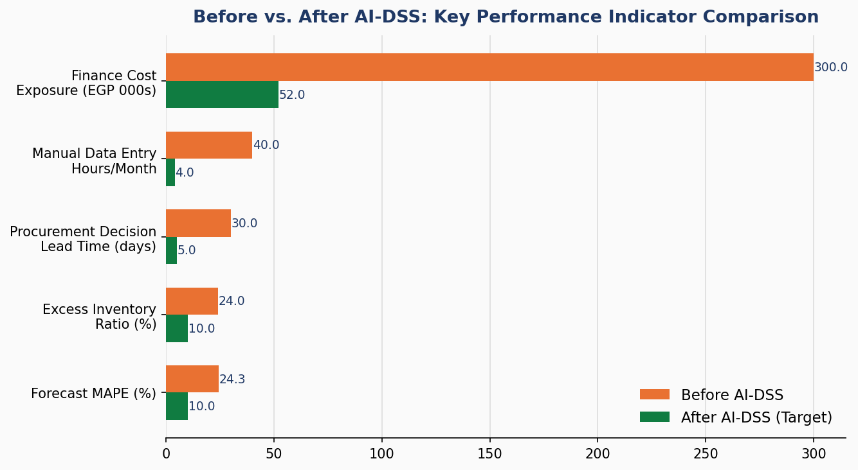
Figure 8: Before vs. After AI-DSS - Key Performance Indicator Comparison (Source: Author, 2026)

5.6 Decision-Making Using Data Mining Techniques
Data mining techniques underpin the analytical framework of this case study. Regression analysis (linear and polynomial) is used to quantify the AMIC and achievement rate relationship. Time-series decomposition identifies seasonal and trend components within AMIC monthly data and lot delivery patterns. Clustering (K-Means) segments historical market conditions into regime categories used as model features. Association rule mining could further identify correlations between specific OEM scheduling behaviors (such as holiday clustering of lot delivery holds) and volume outcomes. Together, these techniques transform raw operational data into structured intelligence that drives both the LSTM model's inputs and the DSS's prescriptive outputs.

6. Digital Transformation Analysis
AI adoption in Mobica's supply chain represents a fundamental shift in how the organization plans, decides, and operates, not merely a technology upgrade. This section analyzes the implications of digital transformation across business processes, automation, organizational culture, and customer experience.

6.1 Changes in Business Processes and Workflows
The pre-AI workflow for Toyota Fortuner lot procurement follows a linear, document-driven process: AAV issues annual volume letter, the Supply Chain team enters volume into ERP as planned demand, Procurement raises TTAP import orders based on OEM forecast, materials arrive, assembly occurs (or does not), and excess inventory is held.
The post-AI workflow is fundamentally redesigned. Monthly AMIC data release triggers an automated RPA process that updates the AI model and regenerates the rolling 6-month forecast. The DSS compares the AI forecast against the OEM forecast and flags deviations. The Supply Chain Manager reviews the DSS dashboard and makes an adjusted procurement decision, potentially delaying, reducing, or splitting the TTAP order, based on probabilistic scenarios rather than a single OEM figure. The BUM reviews the commercial implications and, where deviations are significant, initiates dialogue with AAV for schedule confirmation. This workflow reduces the decision cycle from reactive (post-AAV revision) to proactive (pre-commitment), fundamentally changing the planning dynamic between supplier and OEM.

6.2 Automation of Manual or Repetitive Tasks
Task (Before) | Manual Effort | Automated Replacement (After) | Efficiency Gain
Monthly AMIC report reading and transcription | 4 hrs/month | RPA bot: PDF parse to structured data (under 2 min) | 99% time reduction
FX rate tracking and cost impact calculation | 2 hrs/month | Automated CBE rate feed + ERP cost recalculation | 100% automated
Forecast vs. actual variance analysis | 8 hrs/month | DSS dashboard with real-time variance display | 95% time reduction
Management reporting on program performance | 6 hrs/month | Auto-generated monthly PDF report via RPA | 90% time reduction
Procurement quantity calculation per lot | 3 hrs/lot | DSS prescriptive output: recommended order quantity | 80% time reduction
OEM schedule revision impact assessment | 6 hrs/event | AI model re-run and automated impact report (under 1 hr) | 85% time reduction
Table 6.2.1: Automation Impact - Before vs. After AI-DSS Deployment

6.3 Impact on Organizational Culture and Decision-Making
The transition from OEM-forecast-dependent planning to AI-assisted decision-making requires a cultural transformation within Mobica's Supply Chain and Commercial teams. Key dimensions of this cultural shift include: (1) from deference to data, meaning the organization must develop the confidence to challenge OEM forecasts with its own analytically grounded position; (2) from reactive to proactive, meaning teams must shift from responding to OEM schedule revisions to anticipating them; and (3) from intuition to evidence, meaning commercial negotiations, previously driven by relationship dynamics and experience, must increasingly be anchored to data-supported volume scenarios.
Change management is critical to success. Initial resistance is expected from supply chain staff who may perceive the DSS as threatening their role. Communication must emphasize that the AI system is a decision support tool. It presents scenarios and recommendations, but human judgment remains the final authority. Training programs (Sprint 4) will build internal capability to understand and trust AI outputs, creating a data-literate supply chain team as a lasting organizational asset.

6.4 Customer Experience Improvements
In the B2B automotive supply chain context, customer experience refers primarily to Mobica's performance as a supplier to its OEM customer (AAV/Toyota). AI adoption improves this experience in several ways: (1) improved on-time delivery reliability, by planning to realistic volumes Mobica reduces the risk of material shortages when Toyota unexpectedly accelerates production; (2) enhanced commercial dialogue, as data-supported volume analysis positions Mobica as a more sophisticated supply chain partner; (3) reduced claims and disputes, as fewer excess inventory situations mean fewer late-change order cancellations and financial dispute triggers with TTAP and AAV.

6.5 Before vs. After Digital Transformation Comparison
Dimension | Before (Traditional) | After (AI-Driven)
Planning basis | OEM annual volume letter | AI rolling 6-month forecast with AMIC integration
Forecast accuracy (MAPE) | 24.3% average | Target below 10%
Data integration | Manual Excel and ERP snapshots | Automated real-time AMIC, CBE, and OEM feeds
Procurement decision cycle | Reactive (post-OEM revision, 30+ day lag) | Proactive (120-day pre-commitment horizon)
Risk visibility | Zero, no independent analysis capability | Scenario-based: conservative, base, and optimistic
Reporting | Monthly manual BUM report | Automated real-time DSS dashboard and monthly auto-reports
Commercial negotiation | OEM-dictated volumes accepted | Data-supported counter-forecast with AMIC evidence
Technology | Excel and ERP/MRP (order processing only) | LSTM DSS with RPA automation and ERP integration
Table 6.5.1: Before vs. After Digital Transformation - Mobica Supply Chain

7. ERP Integration & Role (Mandatory)
Enterprise Resource Planning systems are the operational backbone of Mobica's manufacturing and supply chain operations. The AI-DSS does not replace ERP. It enhances it by providing predictive intelligence that feeds into ERP planning modules. This section explains the ERP architecture, integration approach, data flows, and the process flowchart for the AI-enhanced supply chain workflow.

7.1 ERP Modules Involved
ERP Module | System (Indicative) | Role in AI-DSS Integration
Supply Chain Management (SCM) | SAP SCM | Lot scheduling, purchase order management, TTAP import tracking, delivery confirmation recording
Materials Requirements Planning (MRP) | SAP for HANA | BOM explosion, material demand calculation, adjusted demand input from AI-DSS predictions
Finance / Accounts Payable | SAP Finance (FI) | TTAP invoice processing, financing period calculation, interest cost accrual per lot
Sales and Customer Management | SAP SD | AAV delivery schedule management, customer scheduling receipt, invoice generation
Inventory Management | SAP MM | Physical inventory tracking of imported components, WIP, and finished seat assemblies
Reporting and Analytics | SAP BW | KPI dashboards, program performance reports, integration with AI-DSS output data layer
Table 7.1.1: ERP Modules Involved in AI-DSS Integration (Source: Author, 2026)

7.2 How AI Integrates with ERP Systems
The AI-DSS integrates with ERP through a bidirectional data architecture. Historical data flows from ERP into the AI model (input direction), and AI predictions flow back into ERP as adjusted planning parameters (output direction). The integration is implemented via API connectors and RPA-managed file exchanges, avoiding the need for deep ERP customization that could introduce system stability risks or require expensive vendor support.
Specifically: the ERP SCM module exports monthly lot delivery history and open purchase order data via a scheduled report; this data is automatically ingested by the DSS data lake; the LSTM model processes this alongside AMIC and CBE data; the resulting volume prediction is written back to the ERP MRP module as an adjusted demand signal; and the ERP MRP then recalculates material requirements based on the AI-adjusted demand rather than the raw OEM forecast.

7.3 Data Flow Between AI Tools and ERP (Process Flow Diagram)
The following represents the end-to-end process flow and data architecture of the AI-enhanced supply chain system:

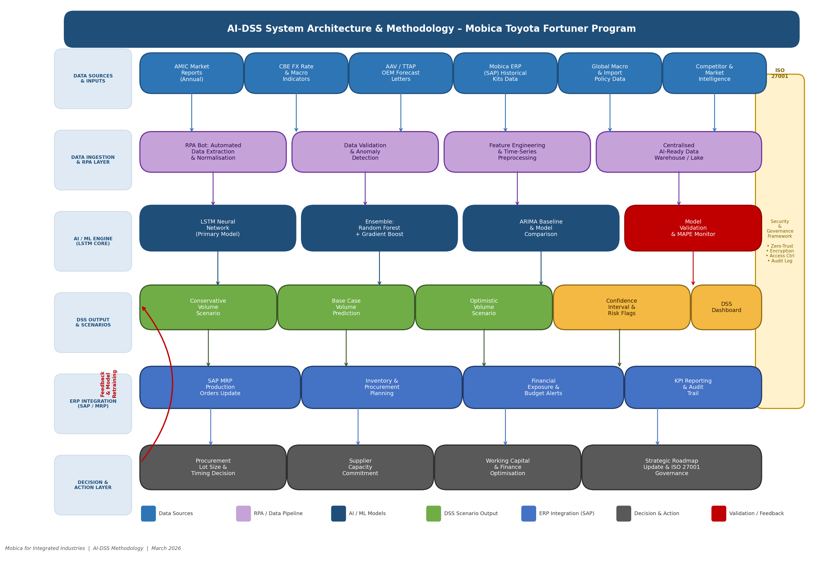
Figure 9: AI-DSS System Architecture & Methodology – Mobica Toyota Fortuner Program (Source: Author, Mobica for Integrated Industries, 2026)

Step | Process Node | Direction | Output
1 | EXTERNAL SOURCES: AMIC Reports + CBE FX + AAV OEM Schedule + TTAP Confirmations | Inbound | Raw data streams
2 | RPA DATA INGESTION BOTS (automated, scheduled) | Processing | Structured feature data loaded to DSS Data Lake
3 | AI-DSS DATA LAKE (Feature Store: time-series + transactional + macro) | Storage | Clean, normalized training and scoring dataset
4 | LSTM + RANDOM FOREST ENSEMBLE MODEL (monthly re-train) | Processing | Volume prediction: 3 scenarios (Conservative / Base / Optimistic)
5 | PRESCRIPTIVE ENGINE (threshold logic, procurement rules) | Processing | Procurement recommendation memo + alert trigger
6 | SUPPLY CHAIN MANAGER DASHBOARD (review and approve) | Decision | Confirmed procurement quantity
7 | ERP API INTEGRATION (adjusted demand signal written to MRP) | Outbound | MRP demand updated in ERP
8 | ERP/SCM MODULE: PURCHASE ORDER RAISED TO TTAP | Execution | TTAP order placed for confirmed lot quantity
9 | PRODUCTION: Seat assembly at 6th October / Abu Rawash | Production | Finished seat systems
10 | DELIVERY TO AAV: Actual volume recorded in ERP | Feedback | Actual volume feeds back to Step 3 as new training data
Table 7.3.1: AI-DSS Process Flow Diagram - Mobica Toyota Fortuner Supply Chain

7.4 Benefits of ERP and AI Integration
- Single Source of Truth: ERP remains the authoritative system of record; AI enriches the planning intelligence without creating parallel data silos
- Automated Demand Signal: MRP calculations automatically reflect AI-adjusted volumes, eliminating manual re-entry of forecast adjustments
- Audit Trail: All AI predictions and their ERP consequences are logged, enabling full post-hoc analysis of model performance versus actual outcomes
- Scalability: Once the Toyota Fortuner integration is validated, the same architecture can be extended to all Mobica OEM programs (GM, Nissan, BMW) without fundamental redesign

7.5 Challenges in ERP Implementation or Customization
- Data Quality: ERP historical data from pre-2022 periods may contain inconsistencies due to manual entry practices; data cleansing is required before model training
- API Availability: Depending on the specific ERP version deployed at Mobica, native API capabilities may be limited, requiring custom middleware or RPA-based file transfer solutions
- Change Management: The MRP module's demand calculation logic must be modified to accept AI-adjusted demand signals, requiring IT configuration effort and user acceptance testing
- Cost of Integration: ERP customization and API development represents a one-time investment estimated at EGP 200,000 to 400,000, which must be justified against the projected savings of EGP 247,800+ per year in excess financing costs

8. Business Impact & Value Creation

8.1 Financial Impact
The financial case for AI adoption in Mobica's Toyota Fortuner supply chain is compelling and quantifiable across three dimensions:
Financial Impact Area | Calculation Basis | Estimated Annual Value
Reduced excess financing cost | 236 units x EGP 4,690 avg finance cost/unit (Base Case scenario) | EGP 1,106,840 per year
Reduced obsolescence risk | Elimination of ~24% excess inventory position on imported TTAP components | EGP 300,000 to 500,000 risk reduction
Commercial negotiation upside | Volume risk premium of 3 to 5% embedded in future lot pricing | EGP 150,000 to 250,000 per year
Operational efficiency (automation) | 40+ person-hours/month freed from manual data tasks | EGP 80,000 to 120,000 per year
Implementation cost (Year 1) | Development, integration, training, infrastructure | (EGP 500,000 to 700,000)
Net ROI: Year 1 | Benefits minus implementation cost | EGP 1,136,840 Annual
Net ROI: Year 2 onward | Full benefits, zero implementation cost | EGP 1,636,840 to 2,436,840 annual
Table 8.1.1: Financial Impact of AI-DSS Implementation - Mobica Toyota Fortuner (Author estimates, 2026)

8.2 Operational Efficiency Improvements
Beyond direct financial savings, the AI-DSS delivers measurable operational improvements: MAPE reduction from 24.3% to below 10% transforms the program from a constant source of planning stress to a predictable operational process; procurement cycle time reduction (from reactive 30+ day lag to proactive 120-day decision horizon) gives Mobica time to negotiate TTAP order adjustments or explore alternative sourcing; and on-time delivery maintenance at greater than 98% ensures Toyota's production line is never disrupted by Mobica-side shortages, protecting the OEM relationship that is the foundation of all future program nominations.

8.3 Strategic Advantages Gained
The strategic value of AI adoption extends beyond the immediate Toyota Fortuner program. First, it positions Mobica as a technologically sophisticated supply chain partner, increasingly a prerequisite for OEM nomination in global automotive supplier strategies. Second, the analytics capability built for Toyota can be replicated across GM, Nissan, BMW, and Mercedes programs, creating a cross-program intelligence platform that compounds its value with each additional dataset. Third, the AMIC data integration framework positions Mobica as the most market-aware automotive supplier in Egypt, a strategic asset in commercial negotiations and in supporting the government's automotive localization agenda.
Academic literature validates the strategic dimension of this advantage, particularly in multi-tier supply network contexts such as the Mobica-TTAP-AAV-Toyota chain:
“In multi-tier supply networks, AI can be used to manage disruptions and fraud, uncover hidden supply chain interdependencies, and formulate what-if scenarios and stress tests.”
-- ScienceDirect, Artificial Intelligence in Supply Chain Management: A Systematic Literature Review (2024), p. 8.
This finding is particularly relevant to the Mobica case: the TTAP-Mobica-AAV value chain is precisely the type of multi-tier network where AI's ability to uncover hidden interdependencies, such as the correlation between AMIC market data and AAV production hold decisions, provides the most strategic value.

8.4 Scalability and Long-Term Sustainability
The AI-DSS architecture is designed for scalability. The data lake, model training pipeline, and RPA infrastructure are program-agnostic. Adding a new OEM program requires only the addition of the relevant historical delivery data and OEM forecast history, without redesigning the underlying system. As Egypt's automotive market grows toward the government's 2030 target of 400,000 to 500,000 units annually, the model will train on an increasingly rich dataset, improving its predictive accuracy over time. The combination of growing data volume, expanding program coverage, and AMIC market maturation makes the AI-DSS more valuable in Year 3 than in Year 1, representing a sustainable competitive advantage.

9. Risks, Ethical Issues & Limitations

9.1 Data Privacy and Security Concerns
The AI-DSS processes sensitive commercial data including OEM production schedules (which are confidential under Toyota's supplier agreements), per-unit pricing and margin data (commercially sensitive), TTAP import quantities and timing (supplier relationship sensitive), and Mobica's program profitability data. Egypt's Personal Data Protection Law (Law No. 151 of 2020) establishes data governance obligations, though it is primarily oriented toward personal data rather than commercial data. More directly applicable are the confidentiality provisions of Mobica's supplier agreements with Toyota/AAV and TTAP, which typically prohibit disclosure of program-specific commercial information to third parties.
The AI-DSS must therefore be deployed within Mobica's private IT infrastructure (on-premise or private cloud), with access controls ensuring that model training data, prediction outputs, and commercial parameters are accessible only to authorized personnel. No Toyota or TTAP data should be shared with cloud AI providers or third-party model training services without explicit contractual authorization.
Samarakoon et al. (2024) specifically examined the security landscape for AI systems in supply chain contexts, proposing a multi-layered defense framework that is directly applicable to Mobica's deployment:
“The research examines the security challenges and potential threats affecting AI model development and deployment, focusing on adversarial attacks, data poisoning, model theft, and compromised third-party components, proposing a multi-layered security framework combining blockchain-based data provenance, federated learning for decentralized model training, and zero-trust architecture to ensure secure deployment.”
-- WJARR-2024-1394, Securing the AI Supply Chain, World Journal of Advanced Research and Reviews, 22(02), pp. 2336-2346 (2024), Abstract.

9.2 Bias in AI Models
The LSTM model trained on 2023 to 2025 data carries an inherent crisis-period bias. The training window encompasses Egypt's most severe automotive market contraction in modern history, a period that may not recur with the same severity. If the model over-weights the crisis pattern, it may systematically under-forecast volumes during the recovery period, causing Mobica to under-procure and miss delivery windows when AAV unexpectedly accelerates production. Mitigation strategies include: scenario-based forecasting (conservative, base, and optimistic) that explicitly addresses a range of outcomes; regular model retraining as new post-crisis data becomes available; and human review of AI recommendations before procurement commitment, ensuring the model's outputs are treated as analytical input rather than authoritative instruction.

9.3 Regulatory or Compliance Issues
The use of AMIC data in a commercial AI model raises questions about data usage rights. While AMIC monthly reports are published and distributed to members, their use in automated commercial decision-making systems should be confirmed as permitted under AMIC membership terms. OEM supplier codes of conduct (Toyota's Global Supplier Guidelines, GM's Supplier Code of Conduct) may contain provisions regarding data handling and system integration that require review before the DSS is connected to OEM scheduling data feeds. Compliance with Egypt's emerging AI governance framework, which is expected to develop in alignment with EU AI Act principles, should be monitored as the system matures.

9.4 Technology Adoption Risks
Technology adoption risks include: over-reliance on model outputs without adequate human judgment, which is particularly dangerous if the model enters a period of systematic error due to a market shift outside its training distribution; IT infrastructure insufficiency, as LSTM model training requires computational resources that may exceed Mobica's current server capacity, potentially requiring cloud investment; and staff resistance, particularly from experienced supply chain professionals who may distrust algorithmic recommendations that conflict with their intuition. The Agile implementation approach (Sprints with incremental delivery and user testing) is specifically designed to mitigate these adoption risks.

9.5 Limitations of AI and ERP Systems
The AI-DSS has inherent limitations that must be acknowledged. The model's training dataset covers only 36 months, a relatively small sample for machine learning, which limits its ability to capture very long-term cyclical patterns or unprecedented market events. The linear regression model used for 2026 predictions assumes a stable relationship between AMIC market size and Toyota Fortuner achievement rate; this relationship may shift as market dynamics change. ERP integration limitations mean that the AI-DSS cannot yet access real-time production floor data or dynamic supplier capacity information, relying instead on scheduled data exports. These limitations are known and are addressed through the scenario-based approach, regular retraining, and human oversight in the decision process.

9.6 Selected ISO 27001 Clauses Relevant to This Case Study
ISO 27001:2022 (Information Security Management Systems) provides the relevant framework for managing the information security risks associated with the AI-DSS. The following clauses are directly applicable:
ISO 27001 Clause | Description | Application to Mobica AI-DSS
Clause 6.1.2 | Information Security Risk Assessment | Mandatory risk assessment before AI-DSS deployment, identifying threats to OEM pricing data, TTAP import data, and AMIC feed confidentiality
Clause 8.1 | Operational Planning and Control | Documented procedures for AI model operation, retraining cycles, data ingestion, and system access management
Clause 9.1 | Monitoring, Measurement, Analysis and Evaluation | Monthly model performance monitoring (MAPE tracking), accuracy audits, and security log review
Annex A 8.2 | Privileged Access Rights | Restricting access to AI model parameters, training data, and commercial outputs to authorized Supply Chain and Commercial team members only
Annex A 8.12 | Data Leakage Prevention | Preventing unauthorized transfer of OEM scheduling data or Mobica commercial data outside the approved IT perimeter
Annex A 5.34 | Privacy and Protection of Personal Information | Ensuring that any personal data incidentally processed complies with Egypt's Data Protection Law No. 151/2020
Table 9.6.1: ISO 27001:2022 Clauses Applicable to the Mobica AI-DSS

10. Recommendations & Future Scope

10.1 Strategic Recommendations for Improvement
Based on the analysis conducted in this research, the following strategic recommendations are made for Mobica's AI adoption journey:
- Immediate (0 to 3 months): Implement AMIC data monitoring as a standard pre-lot procurement checkpoint. Before each TTAP payment commitment, the Supply Chain team should review the latest AMIC monthly report and compare actual market performance against OEM forecast assumptions. A deviation greater than 15% should trigger a formal procurement review, with no AI model required for this first step.
- Short-term (3 to 6 months): Deploy the regression-based volume prediction model (Achievement Rate = 0.000228 x AMIC + 57.26) as a planning parameter overlay. This simple model, validated with R squared = 0.88, can be implemented in Excel and provides immediate analytical value without requiring full AI system development.
- Medium-term (6 to 18 months): Implement the full LSTM-RPA AI-DSS as described in Section 4, following the Agile sprint plan. Prioritize ERP integration in Sprint 1 to ensure data quality, as the accuracy of model outputs is fundamentally dependent on the quality of historical input data.
- Commercial: Negotiate volume risk premium pricing with Toyota/AAV for future program renewal. The statistical evidence (24.3% MAPE, documented shortfall history) provides a compelling data-supported argument for tiered pricing that compensates for the demonstrated volume uncertainty.
- Cross-program: After Toyota Fortuner model validation, extend the AI-DSS to the C43 program, where the forecast failure is most extreme (22.1% achievement), and to the GM program, which provides additional training data for cross-OEM pattern learning.

10.2 Suggestions for Advanced Analytics or AI Upgrades
- Natural Language Processing (NLP): Apply NLP to parse OEM communications, government policy announcements, and news articles for signals that predict market direction changes before they appear in AMIC monthly data, creating a true leading indicator feed.
- Reinforcement Learning: As the DSS accumulates decision history (procurement recommendations versus actual outcomes), reinforcement learning can optimize the recommendation policy over time, learning which types of deviations from OEM forecasts yield the best financial outcomes.
- Digital Twin: Build a digital simulation (Anylogic) of the full Mobica, TTAP, and AAV supply chain, enabling stress testing of procurement strategies under extreme scenarios such as another 50% market contraction or an FX shock to EGP 80 per USD, without operational risk.
- Blockchain for Supply Chain Visibility: Implement blockchain-based lot tracking from TTAP production through Mobica assembly to AAV delivery, creating an immutable audit trail that enhances data integrity for model training and supports ISO 27001 data provenance requirements.

10.3 Future Digital Transformation Opportunities
The AI-DSS represents the first phase of Mobica's digital transformation in supply chain management. Future opportunities include: expansion of the IoT infrastructure within the production facility to capture real-time assembly rates and quality metrics as model features; customer portal development enabling AAV to view Mobica's AI-based volume projections and align scheduling decisions accordingly; and supplier portal integration enabling TTAP to access Mobica's adjusted demand forecasts directly, reducing lead time uncertainty for both parties in the supply chain.

10.4 Expansion of ERP and AI Capabilities
The long-term vision for Mobica's ERP-AI integration is a fully cognitive supply chain platform in which the ERP system natively incorporates AI-generated intelligence across all planning cycles. This includes: AI-enhanced demand planning for all OEM programs; AI-optimized inventory positioning that dynamically adjusts safety stock levels based on predicted achievement rates; AI-driven financial planning that automatically updates the annual budget and rolling forecasts based on market intelligence; and AI-assisted supplier negotiation support that provides TTAP with data-backed volume commitments, enabling better pricing and lead time agreements.
As Egypt's automotive market grows toward the government's 2030 target of 400,000 to 500,000 units annually, suppliers who have built AI-native supply chain capabilities today will be best positioned to scale rapidly, manage inevitable volatility, and build the strategic trust with global OEMs that sustained localization requires. For Mobica, the investment in AI-driven supply chain prediction is not merely a response to the Toyota Fortuner's forecast challenges. It is the foundation of a competitive advantage that will differentiate the company in Egypt's next phase of automotive industry development.

https://dashboard-linker--zerocoolfpl.replit.app/

References
Academic Articles: Supply Chain & AI
1. Springer Nature (2024). Predicting Automotive Industry Supply Chain Disruptions Using Machine Learning: Challenges and Insights. In: Proceedings of the International Conference on Advanced Manufacturing and Industry Applications. https://link.springer.com/chapter/10.1007/978-3-031-99997-0_19 [Cited in: Section 2.1]
2. Ikhlef, H., Benmamoun, Z., & Hachimi, H. (2024). Forecasting supply chain disruptions in the textile industry using machine learning: a case study. Ain Shams Engineering Journal. [Cited in: Section 2.1]
3. Pan, L., & Stark, R. (2022). Interpretable machine learning for engineering change management in the automotive industry. Computers & Industry, 138. [Cited in: Section 2.1]
4. Yang, C. et al. (2023). Supply chain risk management with machine learning technology: a literature review and future research directions. Computers & Industrial Engineering, 175. [Cited in: Section 8.3]
5. Mandala, A., & Vaka, K. (2022). Revolutionizing asynchronous shipments: integrating AI predictive analytics in automotive supply chains. International Journal of AI and Machine Learning. [Cited in: Sections 2.3, 4.2]
6. Terrada, O., El-Khaili, M., & Ouajji, H. (2022). Demand Forecasting Model using Deep Learning Methods. The Scientific Association for Informatics, 13(5). https://thesai.org/Downloads/Volume13No5/Paper_81-Demand_Forecasting_Model_using_Deep_Learning_Methods.pdf [Cited in: Sections 2.3, 4.2]
7. Oyewola, D. et al. (2022). Classifying supply chain datasets using deep learning techniques. Applied Sciences, MDPI. [Cited in: Section 4.2]
8. Taylor & Francis (2024). Artificial intelligence and prescriptive analytics for supply chain resilience: a systematic literature review and research agenda. International Journal of Production Research. https://www.tandfonline.com/doi/full/10.1080/00207543.2024.2341415 [Cited in: Sections 2.4, 5.4]
9. ScienceDirect (2024). Artificial intelligence in supply chain management: A systematic literature review of empirical studies and research directions. Computers in Industry. https://www.sciencedirect.com/science/article/pii/S0166361524000605 [Cited in: Sections 2.4, 8.3]
10. MDPI Information (2025). Revolutionizing Supply Chains: Unleashing the Power of AI-Driven Intelligent Automation and Real-Time Information Flow. Information, 16(1), 26. https://www.mdpi.com/2078-2489/16/1/26 [Cited in: Sections 2.3, 4.1, 8.1]
11. MDPI Applied Sciences (2024). Machine Learning and Deep Learning Models for Demand Forecasting in Supply Chain Management: A Critical Review. Applied Sciences, 7(5), 93. https://www.mdpi.com/2571-5577/7/5/93 [Cited in: Sections 2.3, 4.2]
12. MDPI Future Internet (2026). Predicting Demand in Supply Chain Management: A Decision Support System Using Graph Convolutional Networks. Future Internet, 18(1), 26. https://www.mdpi.com/1999-5903/18/1/26 [Cited in: Section 2.4]
13. ResearchGate (2022). Big Data Analytics in Supply Chain Management: A Systematic Literature Review and Research Directions. MDPI Big Data and Cognitive Computing, 6(1), 17. https://www.researchgate.net/publication/358300092 [Cited in: Section 2.2]
14. ResearchGate / Uncertain Supply Chain Management (2023). The moderating effect of strategic momentum on the relationship between big data analytics capabilities and lean supply chain practices. Uncertain Supply Chain Management, 11. [Cited in: Section 2.2]
15. Samarakoon, et al. (2024). Securing the AI supply chain: Mitigating vulnerabilities in AI model development and deployment. World Journal of Advanced Research and Reviews (WJARR), 22(02), 2336-2346. DOI: 10.30574/wjarr.2024.22.2.1394 [Cited in: Sections 2.5, 9.1]
16. Springer / Journal of Global Optimization (2025). AI-based predictive analytics for enhancing data-driven supply chain optimization. https://link.springer.com/article/10.1007/s10898-025-01509-1 [Supporting reference]
17. Springer / International Journal of Data Science and Analytics (2025). A machine learning-based framework for predicting supply delay risk using big data technology. https://link.springer.com/article/10.1007/s41060-025-00969-8 [Supporting reference]
18. arXiv (2024). AI in Supply Chain Risk Assessment: A Systematic Literature Review and Bibliometric Analysis. https://arxiv.org/html/2401.10895v2 [Supporting reference]
19. SCRUMstudy (2017). SBOK Guide: A Guide to the Scrum Body of Knowledge, 4th Edition. VMEdu Inc. [Cited in: Sections 2.6, 4.4]

Industry and Market References
20. AMIC - Automotive Market Information Council (2021). October 2021 PDF Report. Cairo: AMIC. [Cited in: Sections 3.1, 2.6, 5.1]
21. AMIC - Automotive Market Information Council (2022). October 2022 PDF Report. Cairo: AMIC. [Cited in: Sections 3.1, 2.6, 5.1]
22. AMIC - Automotive Market Information Council (2023). September 2023 PDF Report. Cairo: AMIC. [Cited in: Sections 3.1, 2.6, 5.1]
23. AMIC - Automotive Market Information Council (2025). November 2025 PDF Report. Cairo: AMIC. [Cited in: Sections 2.6, 10.4]
24. Toyota Motor Corporation Global Website. Toyota Marks Start of SUV Assembly in Egypt. https://global.toyota/en/detail/156877 [Cited in: Section 3.2]
25. Egypt Government (2022). Automotive Industry Development Strategy 2022-2030. Ministry of Trade and Industry, Cairo. [Cited in: Sections 2.6, 10.4]
26. International Organization for Standardization (2022). ISO/IEC 27001:2022 - Information Security, Cybersecurity and Privacy Protection. Geneva: ISO. [Cited in: Section 9.6]

Primary / Internal Sources
27. Mobica for Integrated Industries (2025). 2025 Mobica Automotive Company Profile. Internal presentation. [Cited in: Section 3.2, multiple sections]
28. Mobica for Integrated Industries (2025). Mobica KSA Expansion Feasibility Study - Stellantis Seating Project. December 2025. Internal document
29. Mobica for Integrated Industries (2024-2025). Toyota Fortuner Seat & Door Trim Price Negotiation Data Summary. Internal document. [Cited in: Section 3.3]
30. Mobica for Integrated Industries (2025). Toyota Fortuner Lot Delivery Schedule. Internal document. [Cited in: Sections 3.3, 5.1]
31. Mobica for Integrated Industries (2025). Actual Delivery Records - Toyota Fortuner & C43, July 2025. Internal document. [Cited in: Sections 3.3, 5.2]
32. Mobica for Integrated Industries (2025). KPIS Logistics.xlsx - Logistics KPI Framework and Scorecards. Internal document. [Cited in: Section 5.5]

